**R Code for Examples in the book**

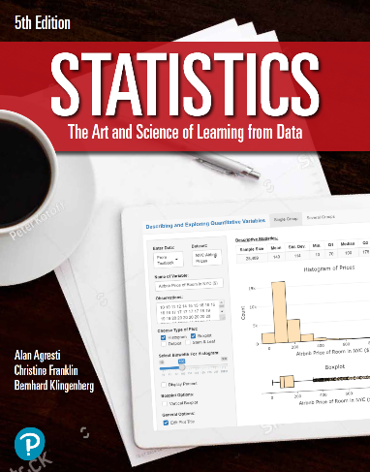

***“Statistics: The Art and Science of Learning from Data”***

**by Agresti, Franklin and Klingenberg, 5th edition**

**Chapter 14**

**Example 9: Corn Yield – Testing the Main Effects**

## Reading in data

corn <- read.csv(file='https://raw.githubusercontent.com/artofstat/data/master/Chapter14/corn_yield.csv')  
head(data, 3)

## fertilizer manure yield  
## 1 high high 13.7  
## 2 high high 15.8  
## 3 high high 13.9

## Fitting in regression model

linReg <- lm(yield ~ fertilizer + manure, data = corn)

## To get the two-way ANOVA

aov <- anova(linReg)  
aov

## Analysis of Variance Table  
##   
## Response: yield  
## Df Sum Sq Mean Sq F value Pr(>F)   
## fertilizer 1 17.67 17.67 6.33 0.02 *  
## manure 1 19.21 19.21 6.88 0.02 *  
## Residuals 17 47.44 2.79   
## ---  
## Signif. codes: 0 '***' 0.001 '**' 0.01 '*' 0.05 '.' 0.1 ' ' 1